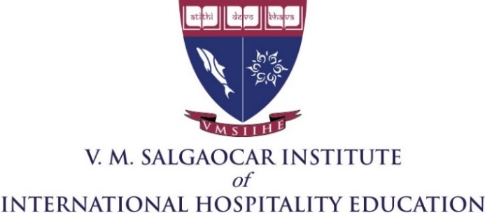

VMSIIHE Newsletter

Scopus Publications
We are happy to announce that Scopus has accepted papers by two of the VMSIIHE faculty.

Ms. Nelissa Alcasoas
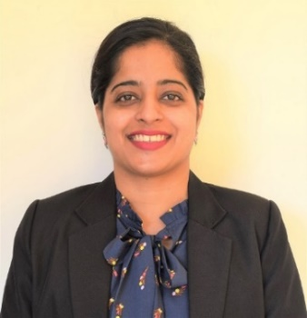
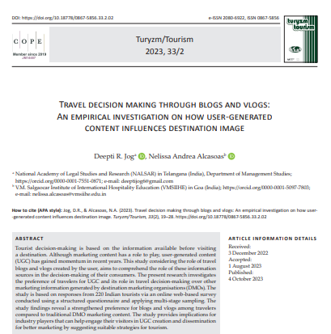
A jointly written paper “Travel decision making through blogs and vlogs: An empirical investigation on how user-generated content influences destination image” by Deepti R. Jog, (NALSAR) in Telangana (India), Department of Management Studies

image/svg+xml https://orcid.org/0000-0001-7551-0871 & Nelissa Andrea Alcasoas, V.M. Salgaocar Institute of International Hospitality Education (VMSIIHE) in Goa (India) has been accepted in Scopus. https://orcid.org/0000-0001-5097-7803, DOI: https://doi.org/10.18778/0867-5856.33.2.02

Ms. Vrinda Vaz
“L’analyse critique de la traduction de Le Tartuffe ou L’Imposteur en Konkani” by Vrinda Vaz, V.M. Salgaocar Institute of International Hospitality Education, Parvatibai Chowgule College of Arts & Science, Goa, Inde & Kshama D. Dharwadkar, Goa University, Goa, Inde. Synergies Turquie n° 15 - 2022 p. 71-82, GERFLINT, ISSN 1961-9472, ISSN en ligne 2257-8404, https://orcid.org/0000-0002-7435-7016, Reçu le 30-10-2022 / Évalué le 04-11-2022 / Accepté le 08-12-2022

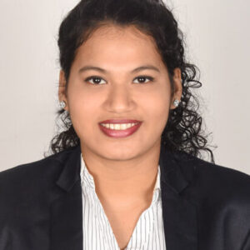
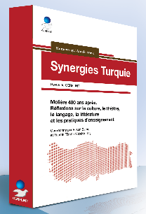

Paper Publications

A paper publication on “A Study on Financial Planning of Working Individuals” by Shameem Memon and Chiara Pereira, former VMSIIHE student, was published in Vishleshan, Bharat @100, Empowering Growth, Opportunities, Economy, Management and Social Study 2023, pp1-4, ISBN : 978-81-953407-7-4

Conference papers

- Semele Sardessai presented a paper titled "Technological trends in food and beverage service: enhancing efficiency and customer satisfaction" at the International Multidisciplinary Conference on Shaping the Future Trends and Insights for Tomorrow (ICSFTIT HYBRID-2023) organized by S.S.G. Pareek, P.G. College, Jaipur in collaboration with Inspira Research Association-IRA, Jaipur, Rajasthan during September 29th- 30th, 2023.

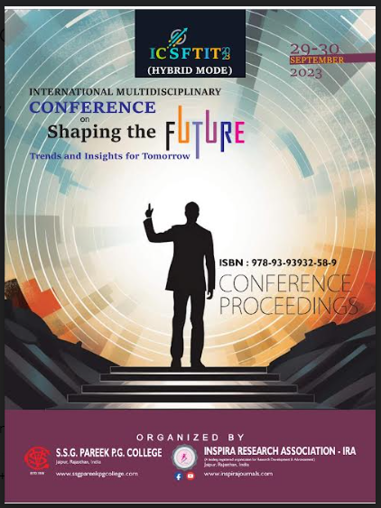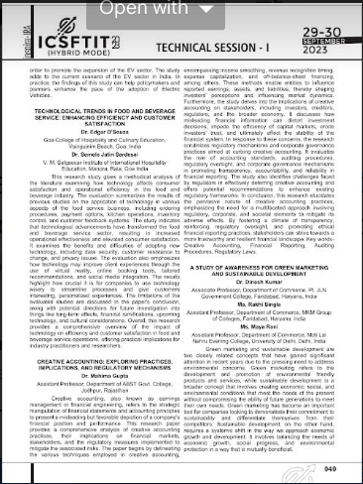

- CMA Shameem Memon, Assist Prof in Financial Acctg and Dr. Makarand Raghunath Sakhalkar, Prof & HOD,Accountancy, Gogate College of Arts and Science and R V Jogalekar College of Commerce, Ratnagiri, jointly wrote a paper. A review of Financial Literacy Initiatives in India published at a conference e-proceeding (ISBN 978-93-92975-04-2), pp 242 to 250, on 25th February 2023 by Govt. of Maharashtra, Ismail Yusuf College of Art, Science, Commerce, Mumbai.

- An overview of Financial Literacy Initiatives in India was also published in the Management Accountant Journal, pp 81 to 86, (ISSN 09723528).

- Frazer Rodrigues, Asst. Prof. in Mgmt., published a paper in an ISO:7021 Certified Journal.
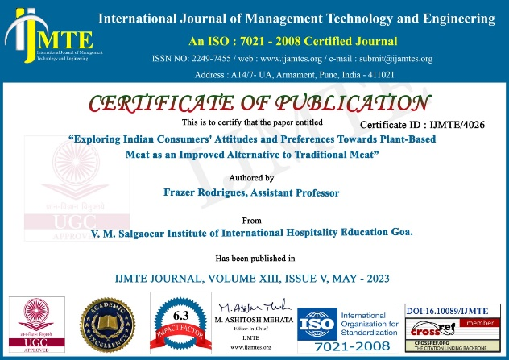

Knowledge Enhancement

Symposium on ‘Tourism and Green Investment’

The Yuva Tourism Club and the Research cell of the institute organised a symposium on ‘Tourism and Green Investment’ on 29thof September 2023 to commemorate World Tourism Day.

Dr. Semele Sardesai, Coordinator of the Research Cell welcomed the gathering. The key note address was given by Dr. Anmol Ahluwalia, Cluster General Manager, Taj Group Hotels, North Goa. This was followed by a presentation of entrepreneurs practicing green tourism: Mr Varun Hegde, founder of Soul Travelling, Mr. Omkar Dharwadkar and Ms. Shraddha Rangnekar from Mrugaya Xpeditions.

This was followed by a panel discussion moderated by Mr. Gavin Dias, General Manager, GTDC.
The panelists were Mr. Nilesh Shah - President TTAG, Mr. Mark Mendes, Department of Tourism, Govt. of Goa, Mr. Ernest Dias, TCI & Managing Committee member.

The Symposium was attended by 128 students and faculty members. Ms. Alethea Baracho, coordinator Yuva Tourism Club proposed the vote of thanks.

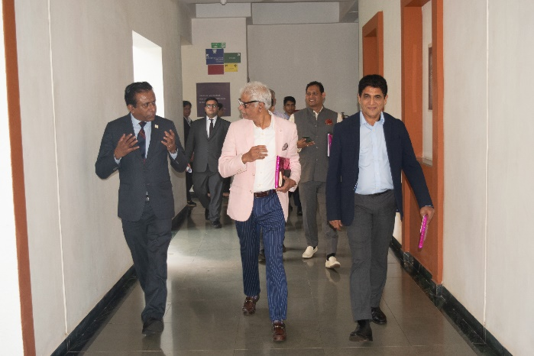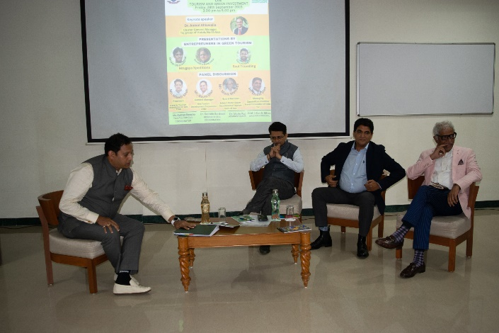

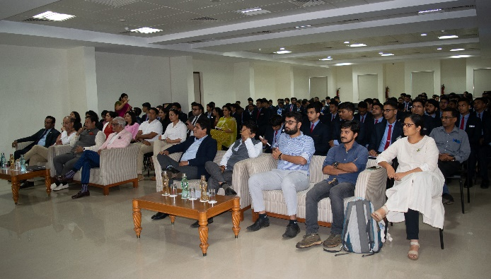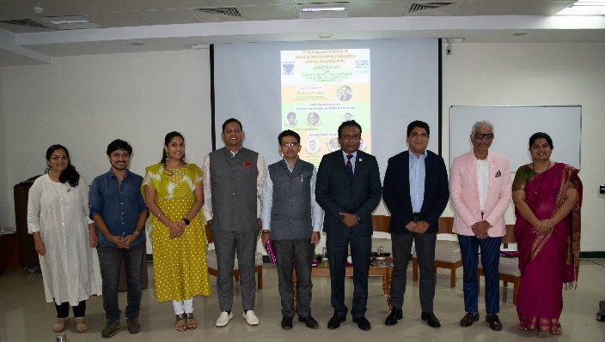

Intellectual Property Rights

The Research Cell of the institute organized a workshop on 'IP Management for Hospitality Industry' for the staff was on 4th August 2023. The resource person was Mr. Pranay Prabhu Gaonkar, IP attorney and founding partner at Menezes Gaonkar & Associates. Forty four participants attended the same.

Mr. Prabhu Gaonkar stated that Intellectual property included ideas, logos, literary works, artistic works, photographs etc. He emphasized that all the IP created in the institute belongs to the institute and the institute can trade mark, copyright, or patent them. He further stressed that intellectual property could be secured to create a distinctive identity in the market. IPR includes Trade Marks, Trade Secrets, Trade Dress, Patents, Geographical Indicator tagging and copyrights. Copyright included published and unpublished original works, including the works in literature, music, art, architecture, software and choreography.

Course on California Wine

Ms. Gauri Patil, Asst. Prof. - F & B Service, completed a Wine Course level 1 conducted by California Wines on 21st August 2023. The resource person was Sovna Puri.

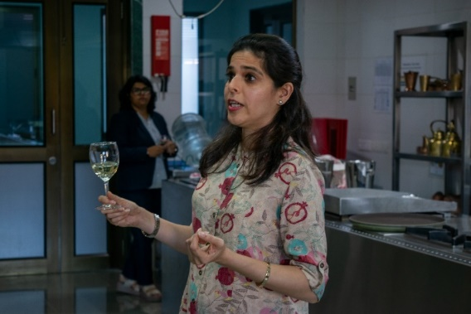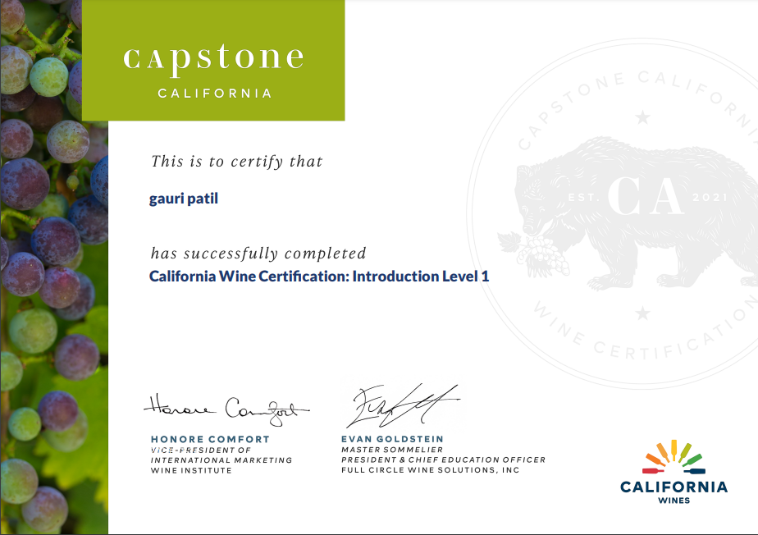

Marketing Conclave 2023: Future of Marketing in Hospitality, Retail, and Service Sectors

Goa Institute of Management in association with GCCI had organized Marketing Conclave 2023: Future of Marketing in Hospitality, Retail, and Service Sectors on 28th July 2023 at GIM Campus, Sanquelim, Goa. Mr. Sudhir Desai, Executive - Corporate Communications, attended the same.

The event shed light on the challenges and opportunities faced by the industries and explored innovative marketing strategies to address them.

Mr. Ralph de Sousa, Immediate Past President of GCCI, Mr. Lalit Saraswat, CEO of Sancaole Technologies, Mr. Saurabh Khanna, General Manager of The Park Hotels, Prof. Shawn Coutinho, Assoc Prof at GIM, Mr. Jack Sukhija, owner of Hotel Panjim Inn, Mr. Hari Kaul, Chairman of GCCI Retail & Wholesale Trade Committee were some of the resource persons.

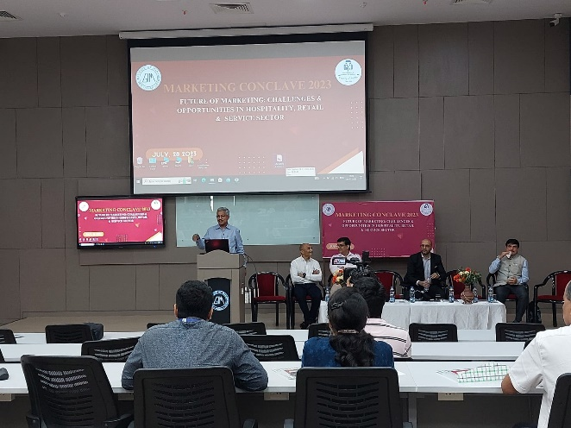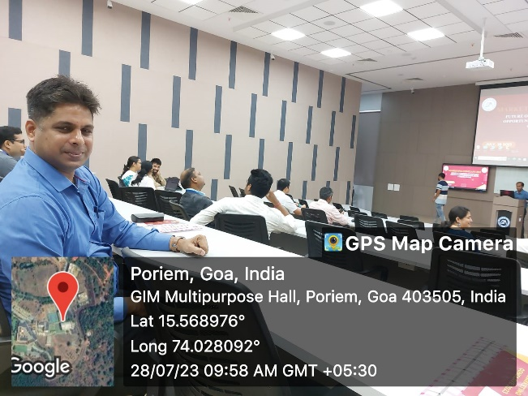

Faculty Knowledge Sharing Program

Ms. Alyce Rodrigues, Asst. Prof. Microbiology (Food Science) attended a faculty knowledge-sharing program organized by ICFAI Business School at Varanda Do Mar- Boutique Hotel, Miramar, Goa, on 5th August 2023

The program aimed to facilitate the exchange of ideas and experiences among educators and explore the opportunities and challenges of digitalization in research and educational settings.

The first talk delivered by Prof. Raghavendra Rao delved into the opportunities and challenges presented by digitalization across different phases in teaching. Dr. Khalid Islam focused on the utilization of Microsoft 365 tools, specifically PowerPoint and Excel, along with Scopus and Mendeley, in research and teaching. The talk aimed to equip educators and researchers with valuable insights into the functionalities of these tools, enabling them to enhance their teaching methodologies and research practices effectively.

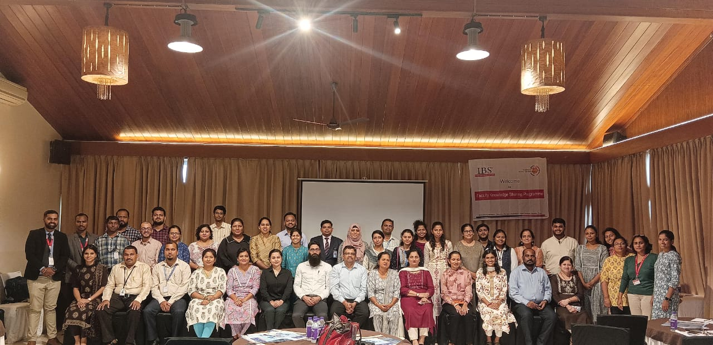

IQAC organized a one-day Workshop on “Getting Ready for NAAC” on 19th October 2023

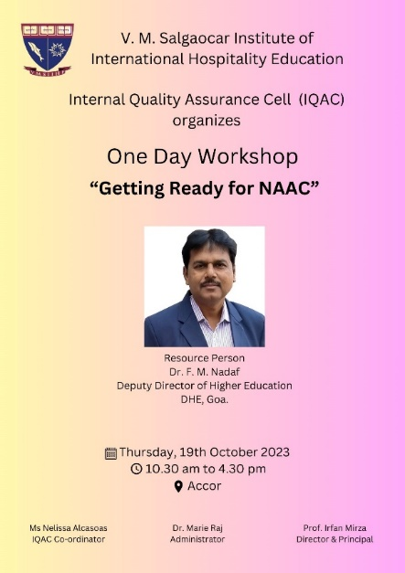
The Resource person was Dr. F. M. Nadaf, Dy. DHE. He is also an official Principal, Borda Multipurpose College.

He shared his valuable insights into the manner which the SSR should be written. He also dealt with the queries that the faculty had. The discussion was extremely fruitful.

Faculty Development Programme (FDP)

- Mr. Sandip Madkaikar, Asst. Professor – Food Production has completed an FDA of 14 days from 1st to 14th August 2023.

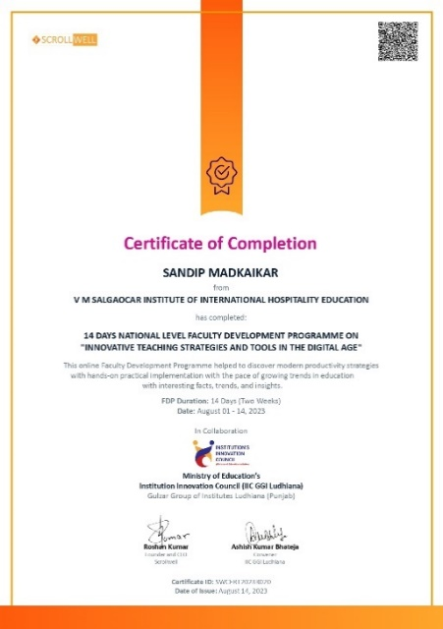

- IQAC of the Institute organized a 7-day FDP on “Benchmarking and DVV” (Data Verification and Validation) from 10th April 2023 to 3rd May 2023 (Non-consecutive days). Dr. Shami Pai, Associate Prof., Damodar College of Commerce & Economics, Margao was the resource person.

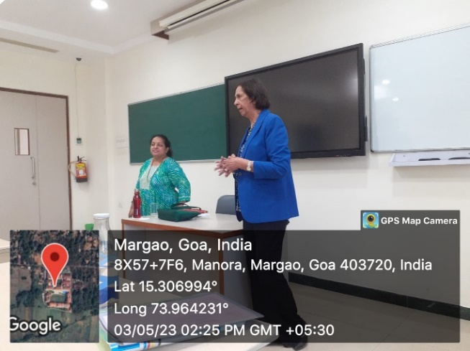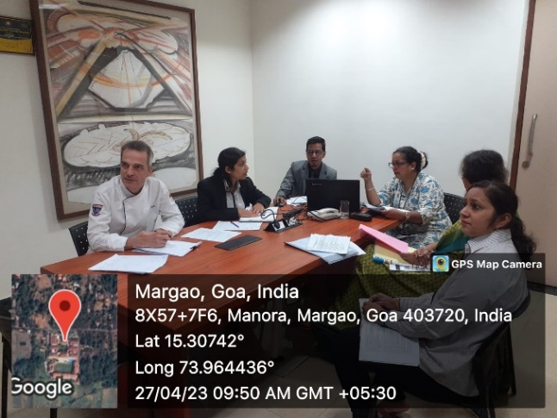

Add-on Courses

- “Critical Thinking and Crises Management” – Faculty in charge: Ms. Shameem Memom.
Resource Person - Mr. Colin Coelho, Trainer and Coach for Life Skills and Communication Skills Margao, conducted the programme.

- A Course on Wines of California was conducted for the T.Y. students by Ms. Gauri Patil, Asst. Prof - F&B services.

Research Programme

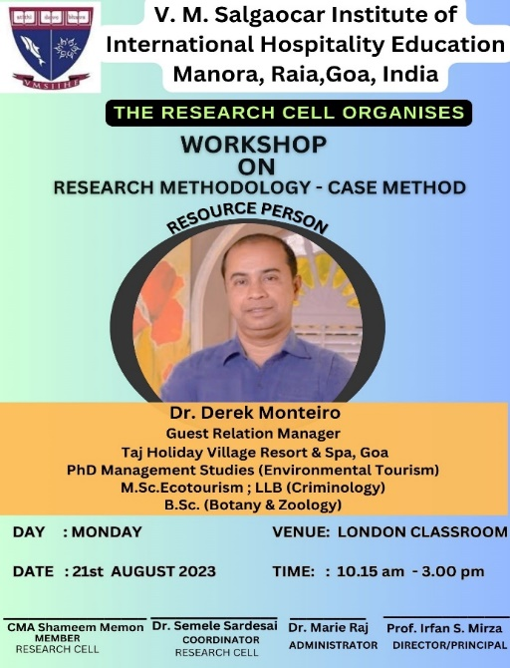
The Research Cell of the institute, organised a workshop on “Research Methodology - Case Study” on 21st August 2023 for the T.Y. M.Sc. students.

Dr. Derek Monteiro was invited as the resource person.

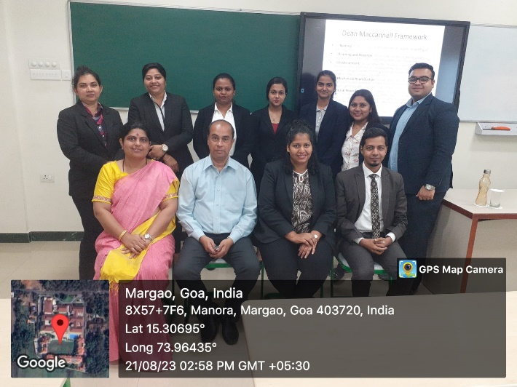

Resource person
- Govt. College of Borda invited Ms. Shameem Memon, Asst. Prof. Financial Accounting, to give a talk on “Opportunities for a Cost and Management Accountant in the Corporate Sector” on 2nd September 2023.
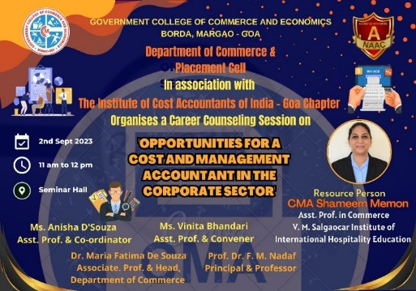

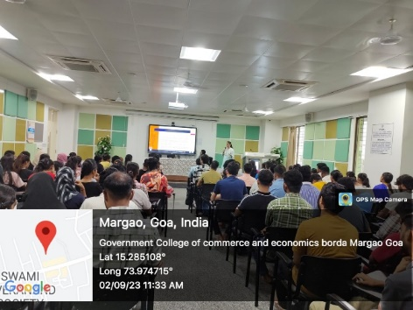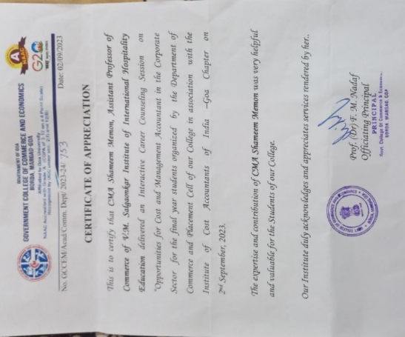

- Ms. Shameem Memon was also invited by the Career Cell of Shree Damodar College of Commerce & Economics to give a talk on the same topic “Opportunities for a Cost and Management Accountant in the Corporate Sector” on 19th August 2023.

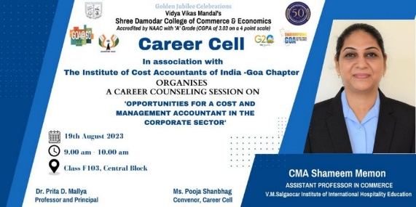

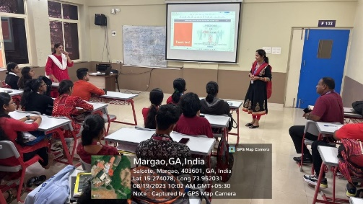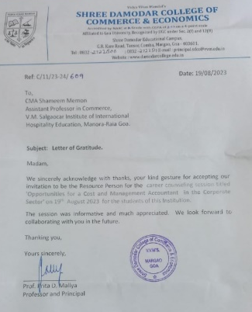

MOUs

- An MOU was signed on 27th October 2023 with MIT-World Peace University (MIT-WPU), Pune, to develop academic and cultural exchange in the domain of student and faculty mobility. It will involve an exchange of programmes, courses, seminars, special lectures, workshops etc. Prof. Sharma & Prof. Mirza signed and exchanged the MOUs.

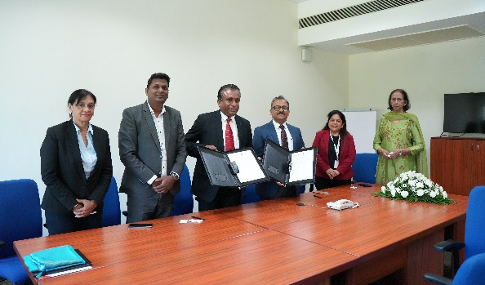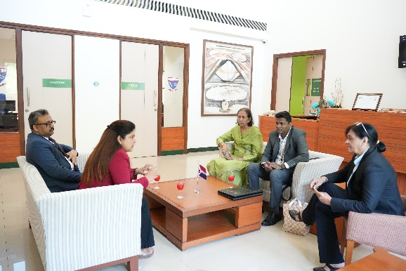

- An MOU was signed on 20th April 2023 with DSES’ V. M. Salgaocar College of Law, Miramar, Goa, to promote collaborative research, to facilitate exchange of faculty, research scholars and students, to associate in research initiatives and to undertake all related activities.

Events at the Institute

Founder’s Day – Honouring the memory of late Shri Vassudev M. Salgaocar

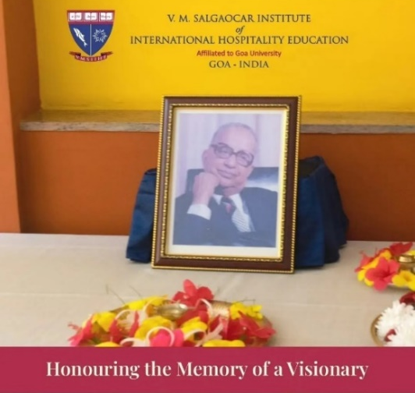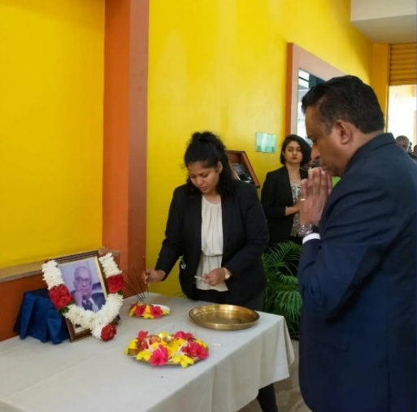

International Chef Day

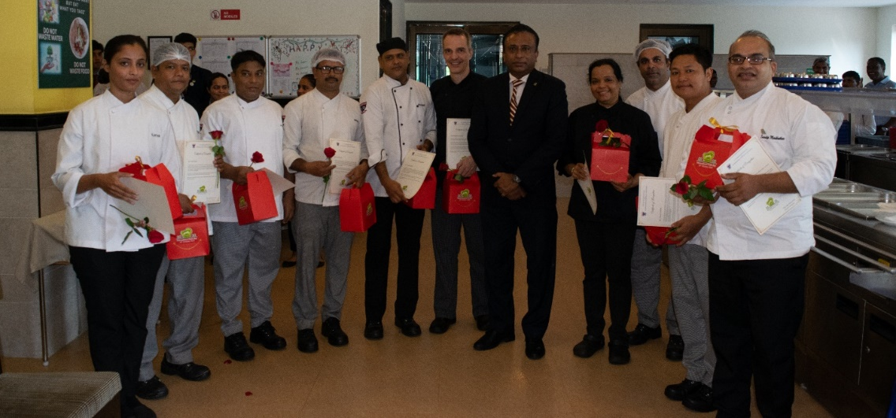

All the chefs of VMSIIHE were felicitated with a Certificate of Appreciation and a memento which was given on the occasion of International Chefs Day on 20th August 2023.

The 77th Independence Day Celebrated at VMSIIHE

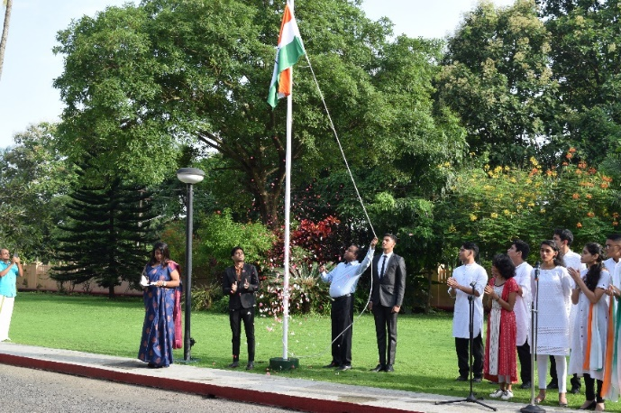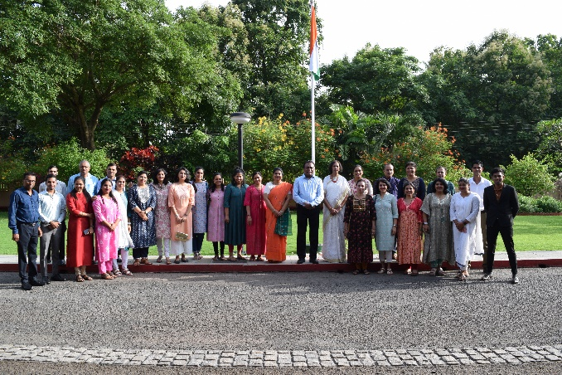

Annual Fruit Mixing Ceremony
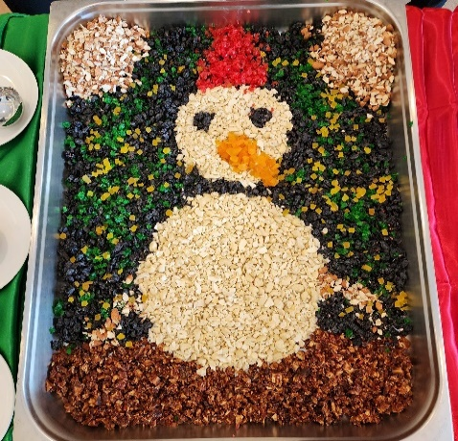
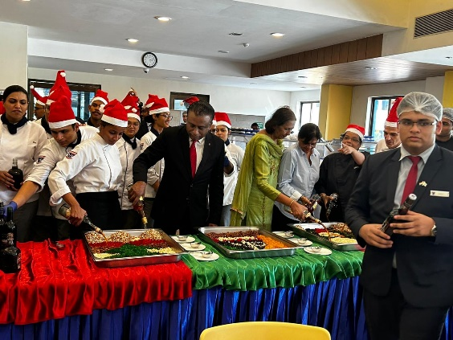
The spirit of Christmas has descended upon VMSIIHE. This cherished Christmas tradition, organized by the Cuisine Club, brought together students and staff, to usher in the festive season with great enthusiasm.

International Bread Day by our Pastry Chefs and Students

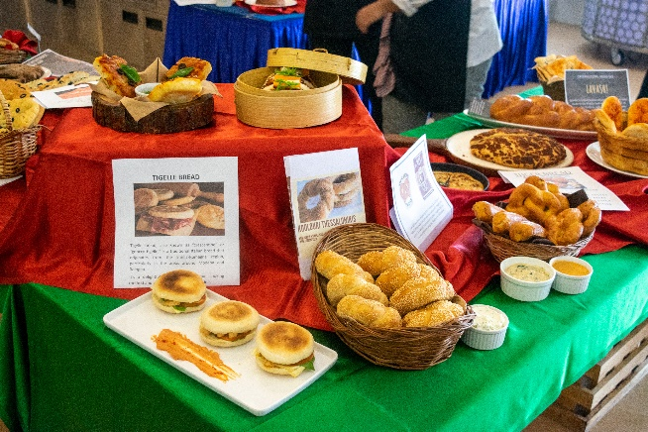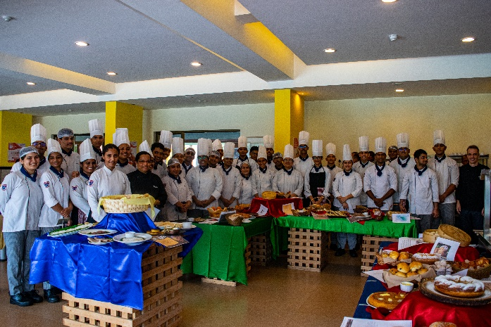

Blood Donation on 7/9/2023 for a noble cause

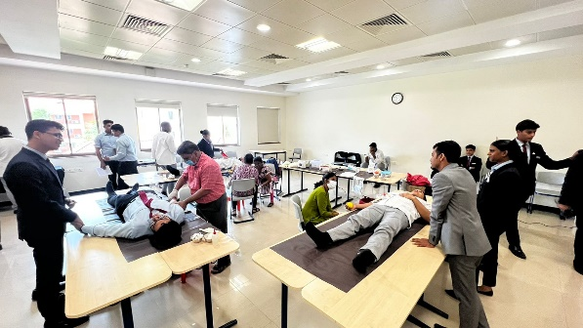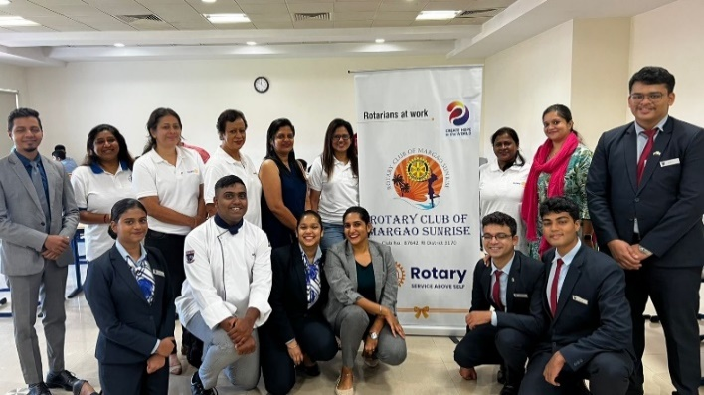

The festival of Onam was celebrated on 5/9/2023

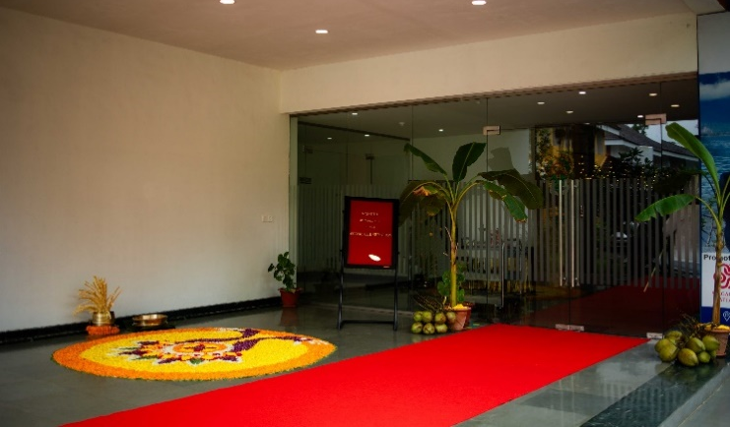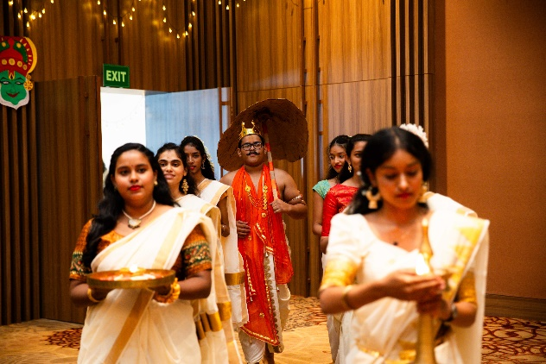

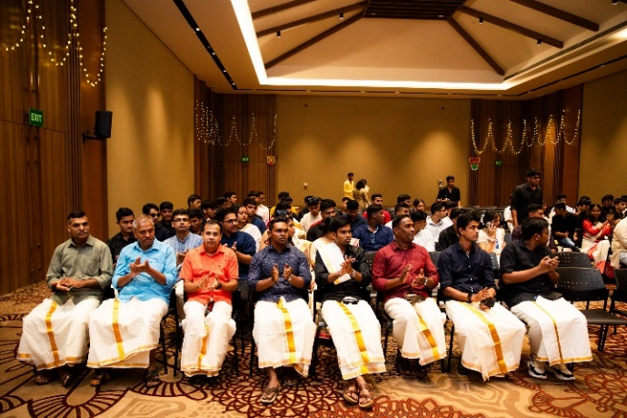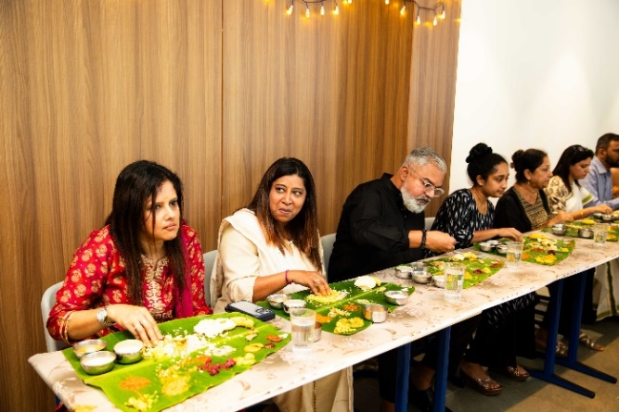

Prof. Irfan Mirza Dr. Marie Raj Sushma C. Lotliker
Editor in Chief Editor Sub Editor

V. M. Salgaocar Institute of International Hospitality Education
Manora-Raia, Salcete, Goa-403720, India
Tel +(832) 6623000 Fax +91 (832) 6623111
info@vmsiihe.edu.in www.vmsiihe.edu.in

